CSA0502 – QUERY PROCESSING FOR DATASCIENCE
Lab Programs
3.Write a Pandas program to display the details of jobs in descending sequence on job
title.
CODE:
import pandas as pd

# Dataset
data = {
"JobID": [1, 2, 3, 4],
"JobTitle": ["Analyst", "Manager", "Clerk", "Sales Executive"],
"Salary": [50000, 80000, 30000, 45000]
}

df = pd.DataFrame(data)

print("Original Dataset:")
print(df)

print("\nJobs in Descending Order:")
print(df.sort_values(by="JobTitle", ascending=False))

OUTPUT:
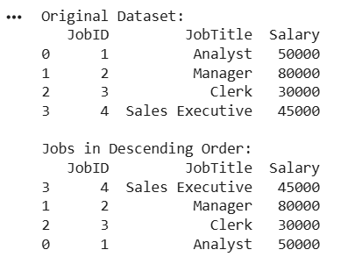

4. Create a line plot of Alphabet Inc. stock prices
CODE:
import pandas as pd
import matplotlib.pyplot as plt

# Dataset
data = {
"Date": ["2024-01-01", "2024-01-02", "2024-01-03",
"2024-01-04", "2024-01-05"],
"Close": [140, 142, 141, 145, 148]
}
df = pd.DataFrame(data)
df["Date"] = pd.to_datetime(df["Date"])
plt.plot(df["Date"], df["Close"], marker="o")
plt.title("Alphabet Inc. Stock Prices")
plt.xlabel("Date")
plt.ylabel("Closing Price")
plt.grid(True)
plt.show()

OUTPUT:
